**Paperless Client**

**envoy**

**expense or outlay**

**persuade**

**generic term for a sacrifice the gods**

**letter**

**Version 1.0**

# 

# CONTENTS

CONTENTS 1

1 Overview 1

1.1 Introduction to the system 1

1.2 System operating environment 1

1.3 Copyright Notice 1

2 Software Installation and Configuration 1

2.1 Software Installation 1

3 Software Functions and Instructions for Use 1

3.1 Welcome page, sign-in page 1

3.1.1 Welcome page 2

3.1.2 Sign-in page 2

3.2 Places of attendance 3

3.2.1 Agenda of the meeting 3

3.2.2 Meeting information 3

3.2.3 Minutes of meetings 4

3.2.4 Conference services 4

3.2.5 Reading a USB flash drive 5

3.2.6 Temporary documents 5

3.2.7 Sending information 6

3.2.8 Voting by ballot 6

3.2.9 System notifications 7

3.2.10 Check-in information 7

3.3 Chairmanship 8

3.3.1 Information control 8

3.3.2 Voting control 9

3.3.3 Signal control 9

3.3.4 Centralized control 10

3.3.5 Online control 10

3.3.6 Changing themes 11

3.3.7 Opening the background 11

3.3.8 Publication of announcements 12

3.4 Hover Menu 12

3.5 System Setup 13

# 1 Overview

## 1.1 Introduction to the system

Paperless client software

## 1.2 System operating environment

The following hardware and software environments are required for the operation of the system:

|  |  |
| --- | --- |
| **operating system** | Windows 7, Windows 10, Android 6.0 and above |

## 1.3 Copyright

You may not distribute copies of the Software Product to others for profit. You may not reverse engineer, decompile, or disassemble the Software Product.

# 2 software installation and configuration

## 2.1 Software installation

Install the software with one click through the installation package.

# 3 Introduction to software functions and instructions for use

## 3.1 Welcome page, sign-in page

After installing the software, you will be taken to the welcome page. If meeting check-in is enabled for the meeting, clicking "Go to Meeting" will take you to the check-in page.

### 3.1.1 Welcome page

Click on the application to open the software and go to the Welcome page, which displays information about the meetings opened in this session. As shown in Figure 3.1.1-1.

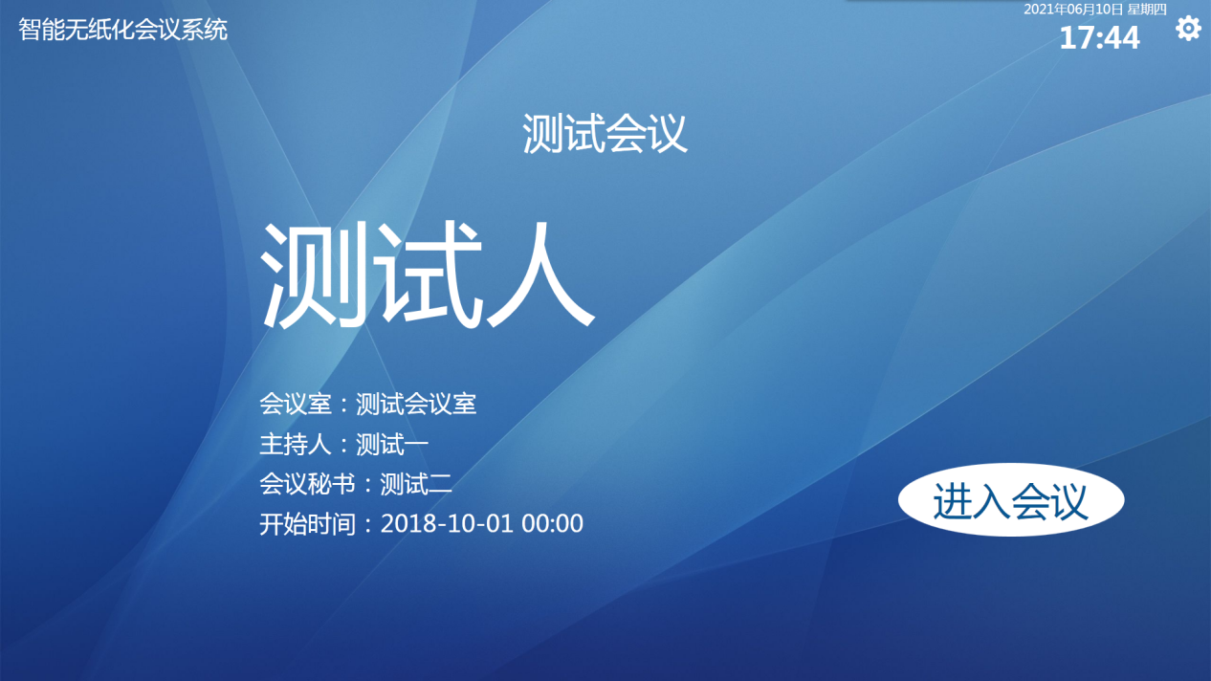

Figure 3.1.1-1 Welcome Page

### 3.1.2 Sign-in page

This session goes to the Check-In page if Check-In is enabled. This is shown in Figure 3.1.2-1. If check-in is not enabled, the session goes directly to the function home page.

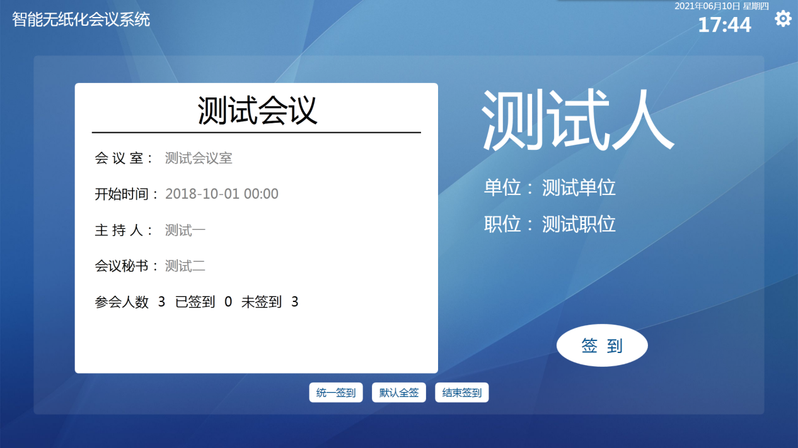

Figure 3.1.2-1 Check-in Page

## 3.2 Seating

There are 10 menus under the Attendance function module. They are Meeting Agenda, Meeting Information, Meeting Minutes, Meeting Services, Read USB Flash Drive, Temporary Files, Send Information, Voting, System Notification, and Check-in Information.

### 3.2.1 Agenda of the meeting

Entering the meeting function home page takes you to the meeting agenda page by default. As shown in Figure 3.2.1-1.

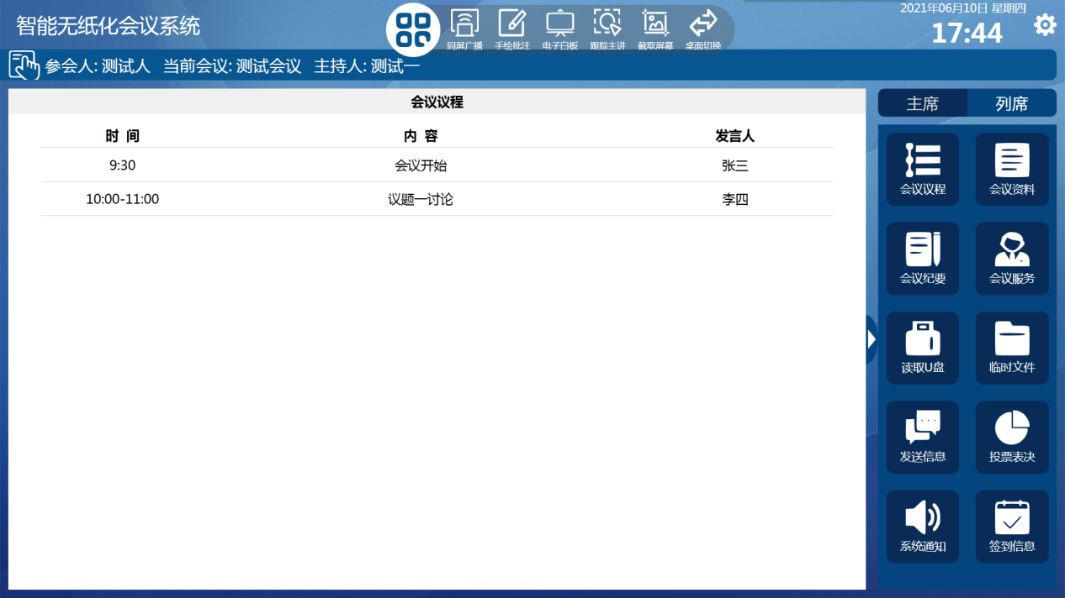

Figure 3.2.1-1 Meeting Agenda Screen

### 3.2.2 Meeting information

Meeting materials are the management of meeting topics. Under each topic, you can upload the corresponding meeting materials, which can be viewed and edited online, and the edited documents can be viewed after being saved and stored in the annotation file of the meeting minutes. As shown in Figure 3.2.2-1.

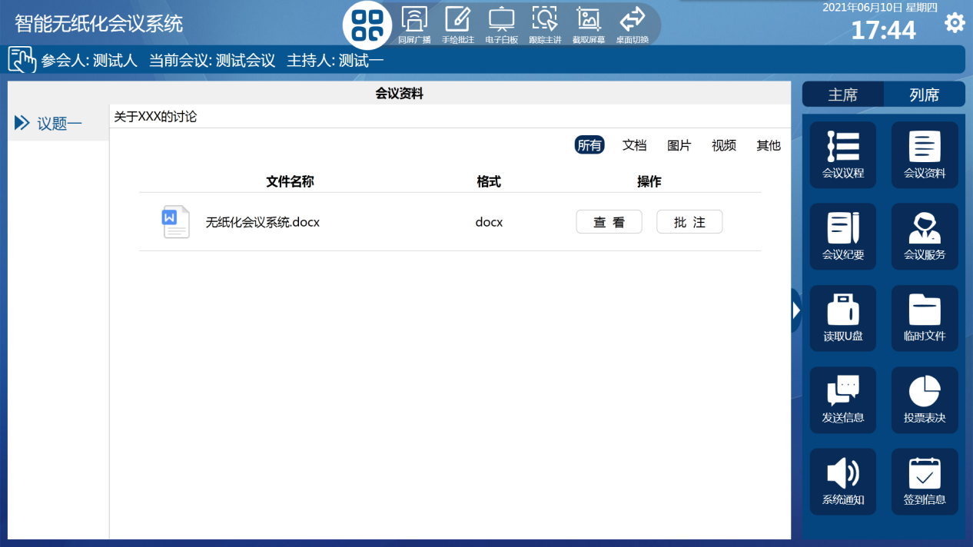

Figure 3.2.2-1 Meeting Information Screen

### 3.2.3 Minutes of meetings

Meeting minutes can be viewed as hand-drawn annotations, electronic whiteboards, annotated documents, and documents saved with screenshot information. As shown in Figure 3.2.3-1.

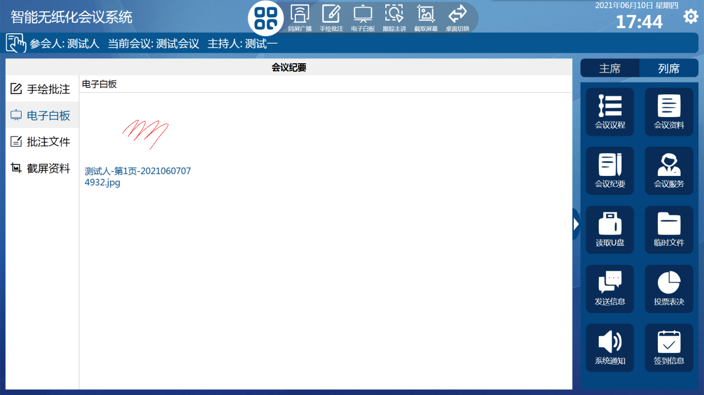

Figure 3.2.3-1 Minutes Screen

### 3.2.4 Conference services

The conference service can send the conference request to the backend administrator, and you can choose to send it directly by selecting the preset 8 kinds of contents, or you can send it by customizing the input request contents. As shown in Figure 3.2.4-1.

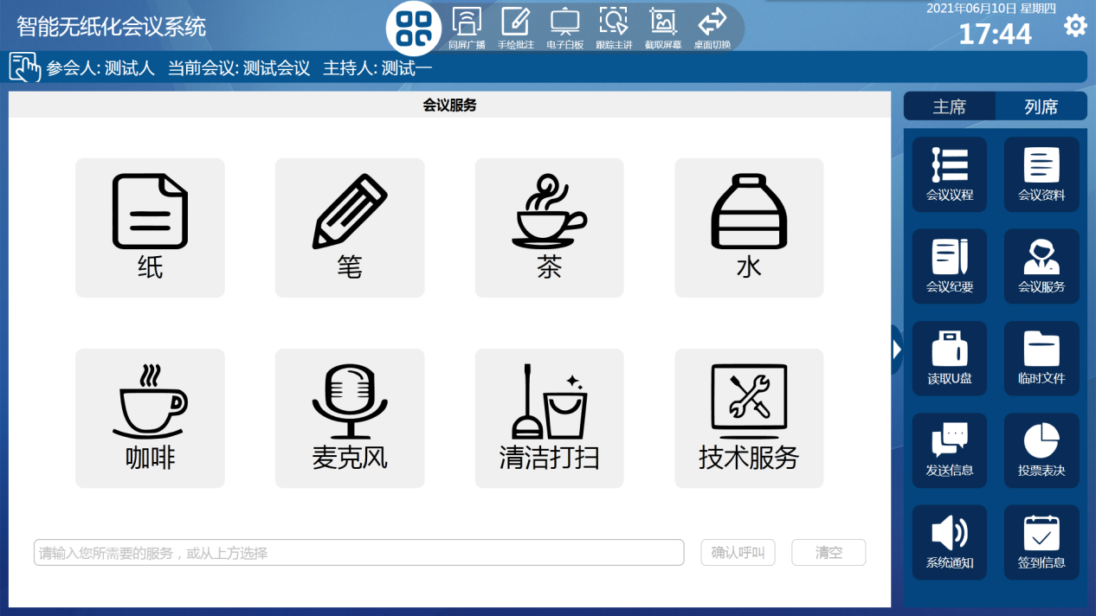

Figure 3.2.4-1 Conference Services Interface

### 3.2.5 Reading a USB flash drive

Read USB flash drive can read files from external USB flash drive devices, which can be viewed directly online or imported into temporary files. As shown in Figure 3.2.5-1.

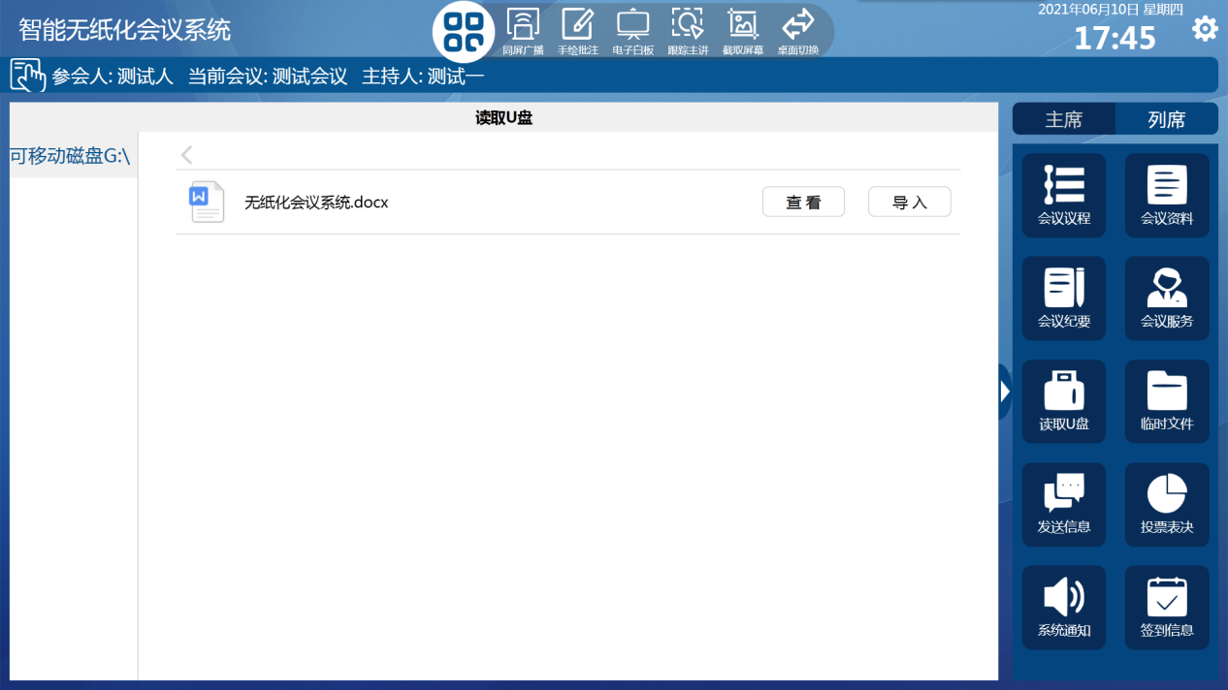

Figure 3.2.5-1 Read USB flash disk interface

### 3.2.6 Temporary documentation

Temporary files can be imported by uploading files through the backend or through a USB flash drive. They can be viewed online and exported to the USB flash drive device. As shown in Figure 3.2.6-1.

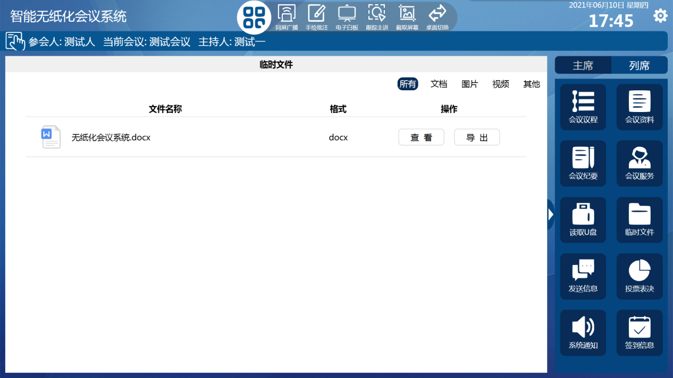

Figure 3.2.6-1 Temporary File Interface

### 3.2.7 Sending information

Sending a message is based on the chat window form, which can be sent one-to-one or to the background administrator. As shown in Figure 3.2.7-1. Discussion groups can also be created, and group chat is available. As shown in Figure 3.2.7-2.

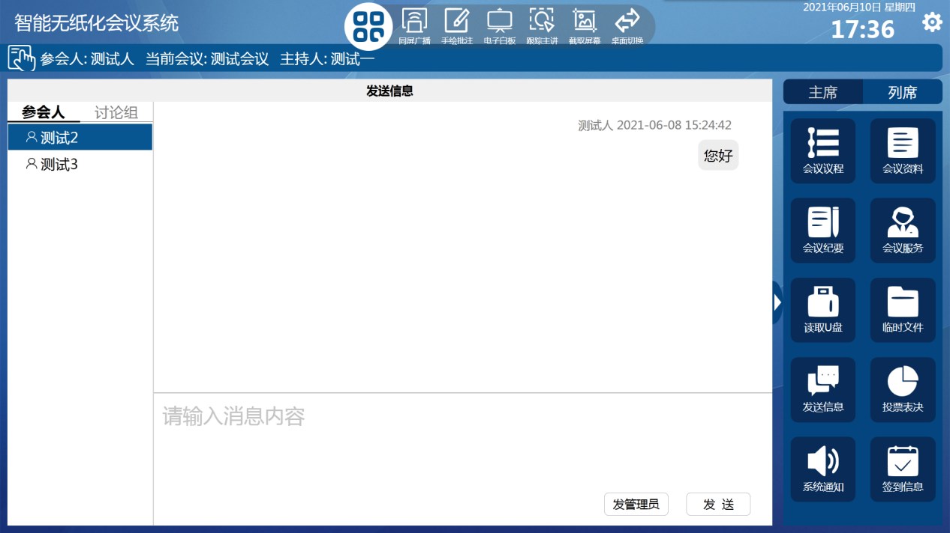

Figure 3.2.7-1 Send Message Screen

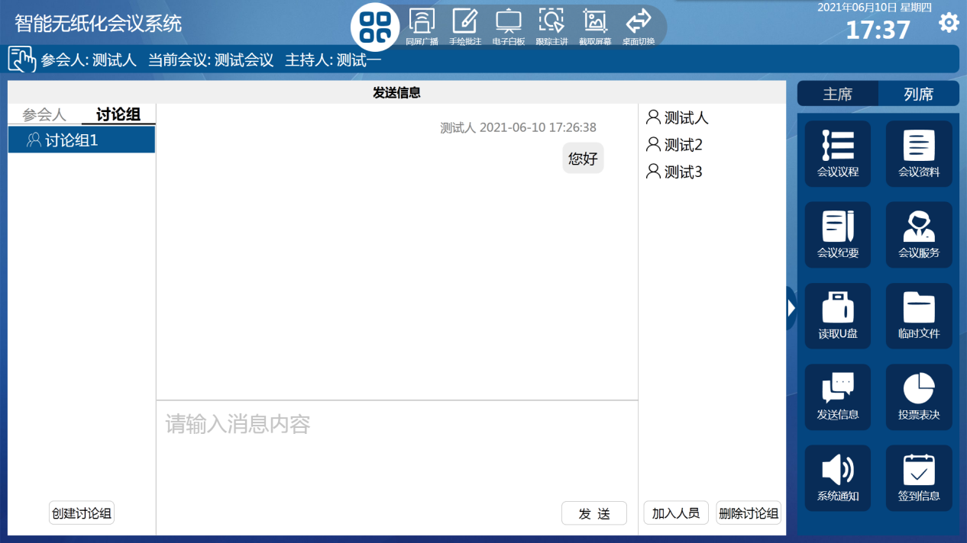

Figure 3.2.7-2 Send Message Discussion Group Interface

### 3.2.8 Voting

Polling allows you to view the polling information for this session. As shown in Figure 3.2.8-1.

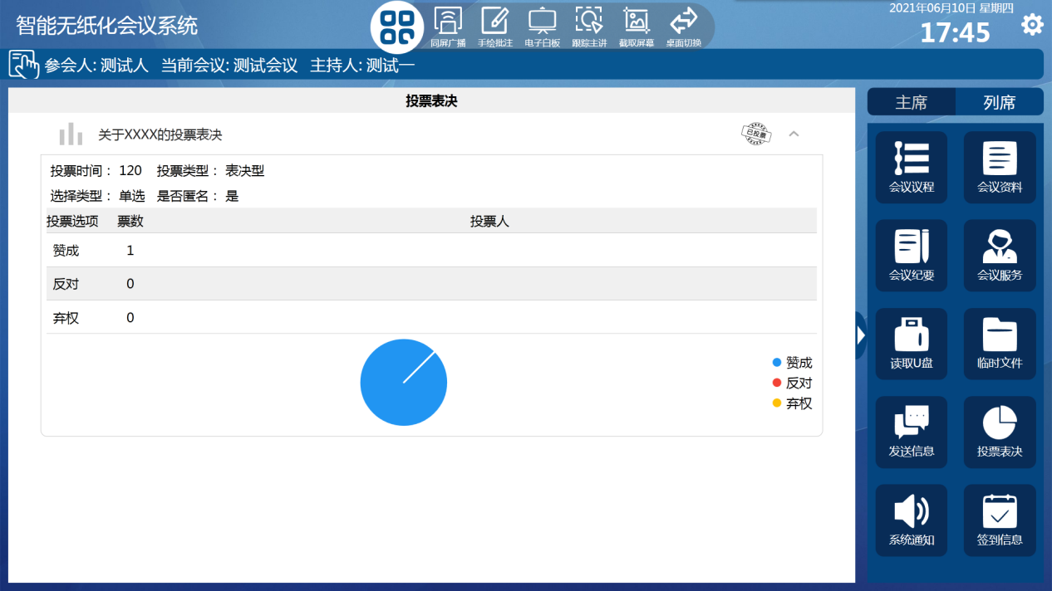

Figure 3.2.8-1 Voting Screen

### 3.2.9 System notifications

System Notifications allows you to view notifications sent by the background administrator. As shown in Figure 3.2.9-1.

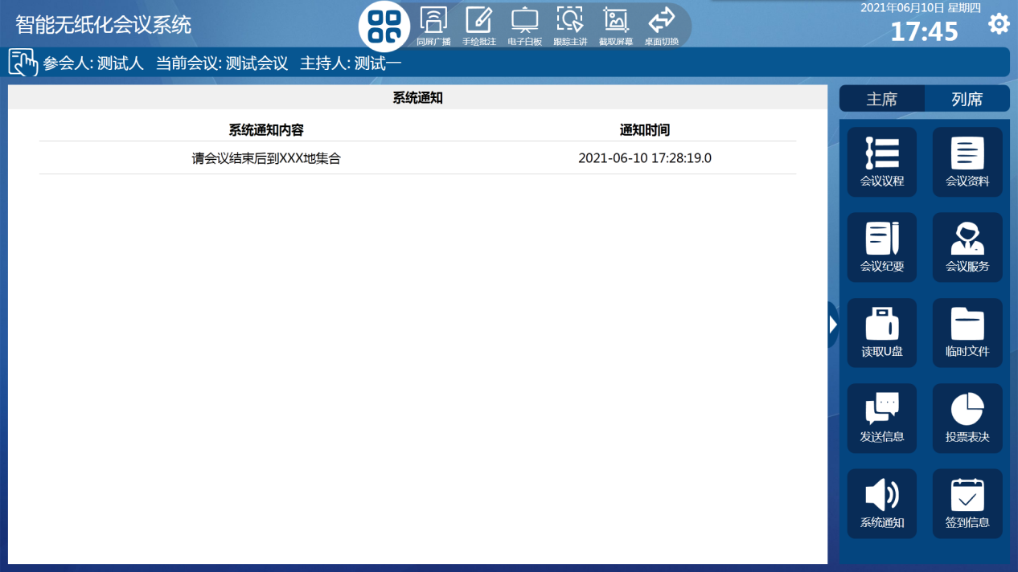

Figure 3.2.9-1 System Notification Interface

### 3.2.10 Check-in information

Check-in information allows you to view the current check-in status of this meeting, and the chairman's authority can control the check-in of this meeting. As shown in Figure 3.2.10-1.

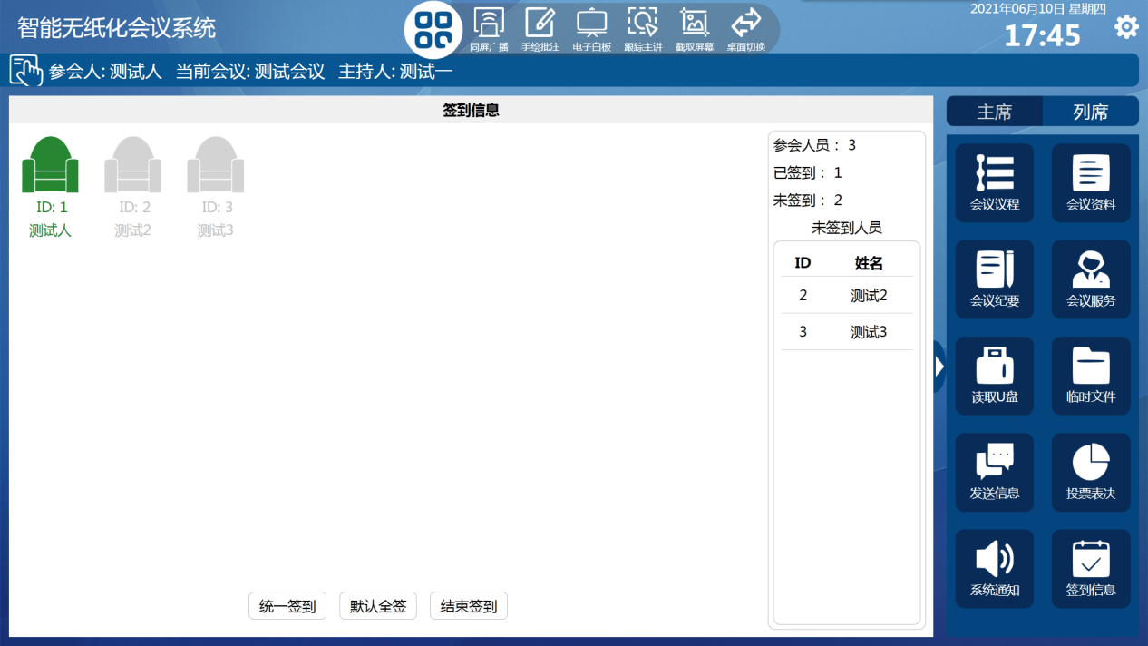

Figure 3.2.10-1 Check-in Information Screen

## 3.3 Chairmanship

There are 8 menus under the chairman function module. They are Profile Control, Voting Control, Signal Control, Centralized Control, Online Control, Change Theme, Open Backstage, and Announcement Release.

### 3.3.1 data control

Profile Control allows you to control the display/hiding of meeting profile topics, and only topics that are turned on will be displayed in the meeting profile. As shown in Figure 3.3.1-1.

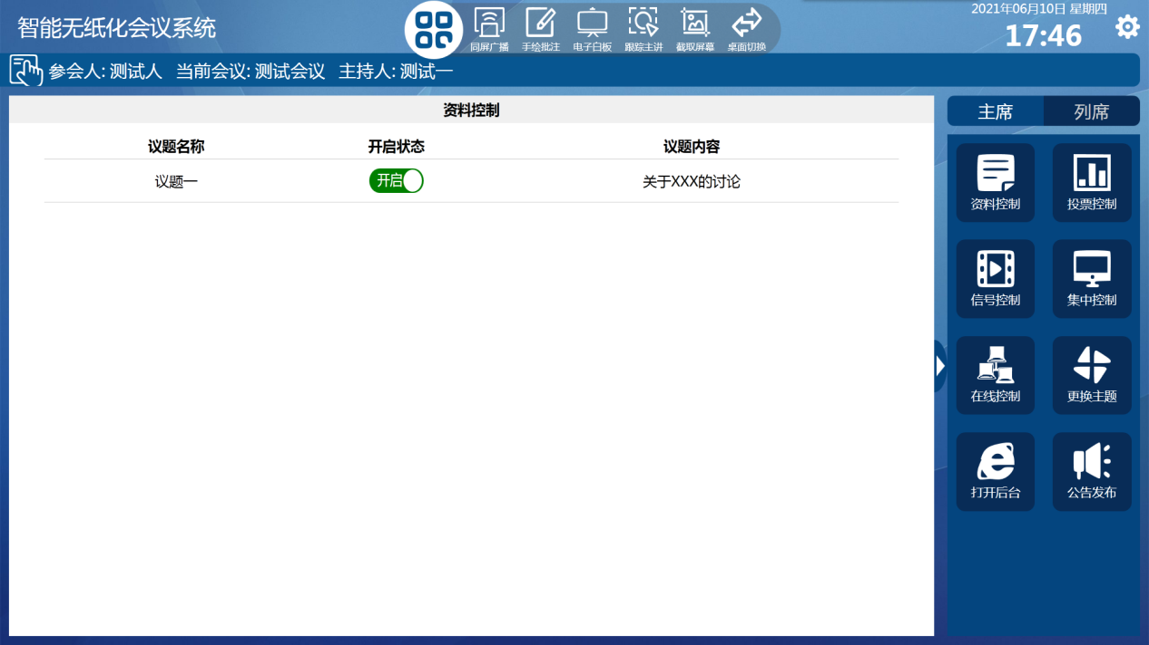

Figure 3.3.1-1 Profile Control Interface

### 3.3.2 Voting Control

The Polling Control controls the opening\closing\resetting of the polls, and can display the polling results for the polls that have already been cast. As shown in Figure 3.3.2.

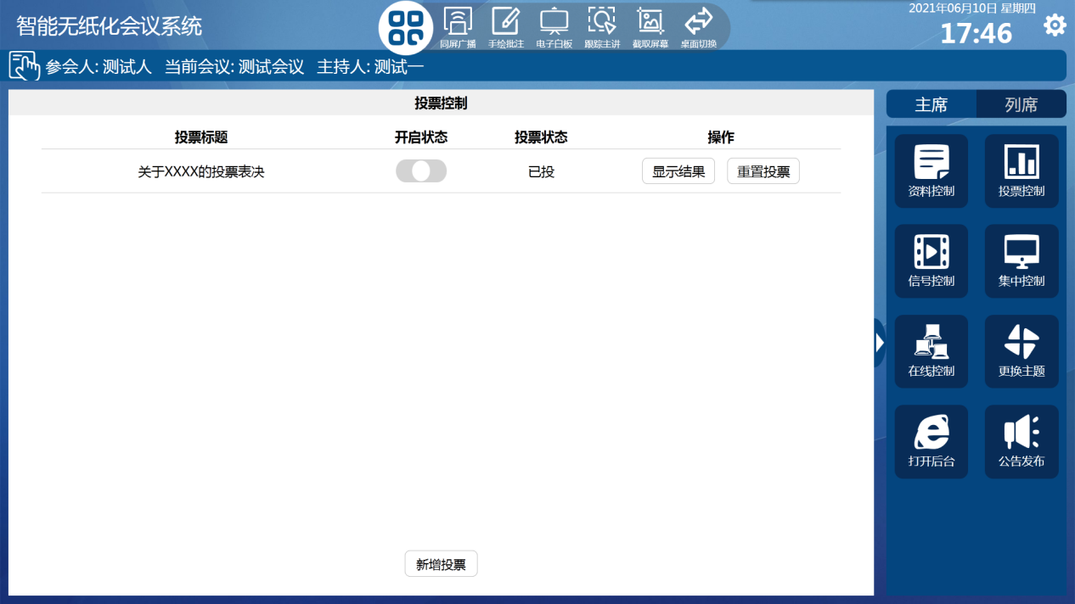

Figure 3.3.2-1 Voting Control Interface

### 3.3.3 Signal Control

Signal control can control the internal signal or external signal broadcasting to any terminal and large screen on the same screen. As shown in Figure 3.3.3-1.

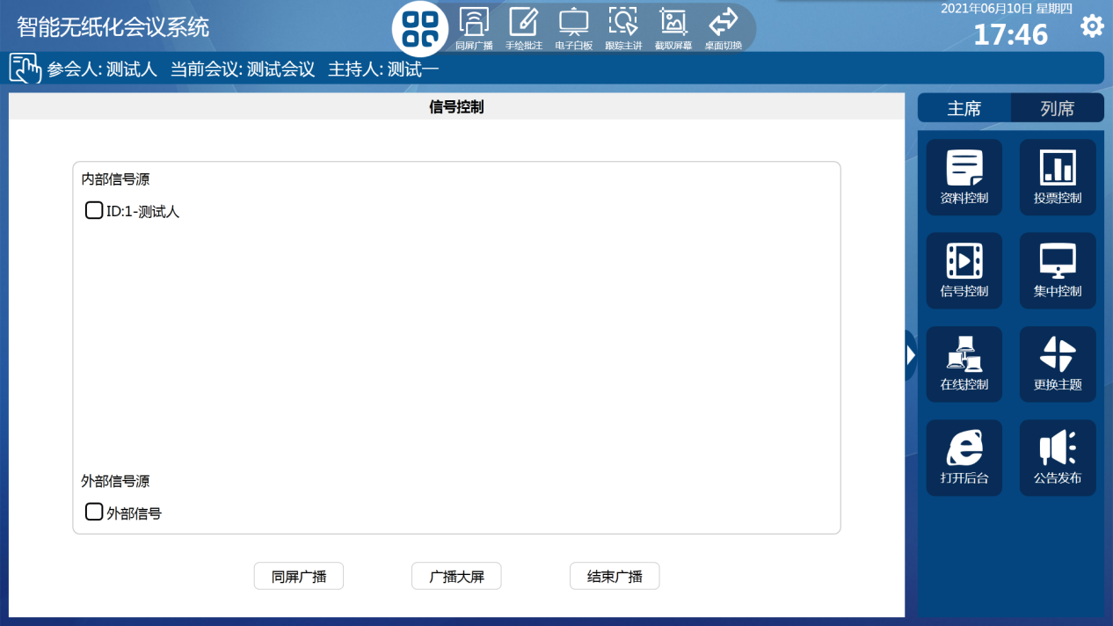

Figure 3.3.3-1 Signal Control Interface

### 3.3.4 Centralized control

Centralized control allows you to control all terminals in this conference to perform operations such as jumping pages, closing the conference, and shutting down the computer. As shown in Figure 3.3.4-1.

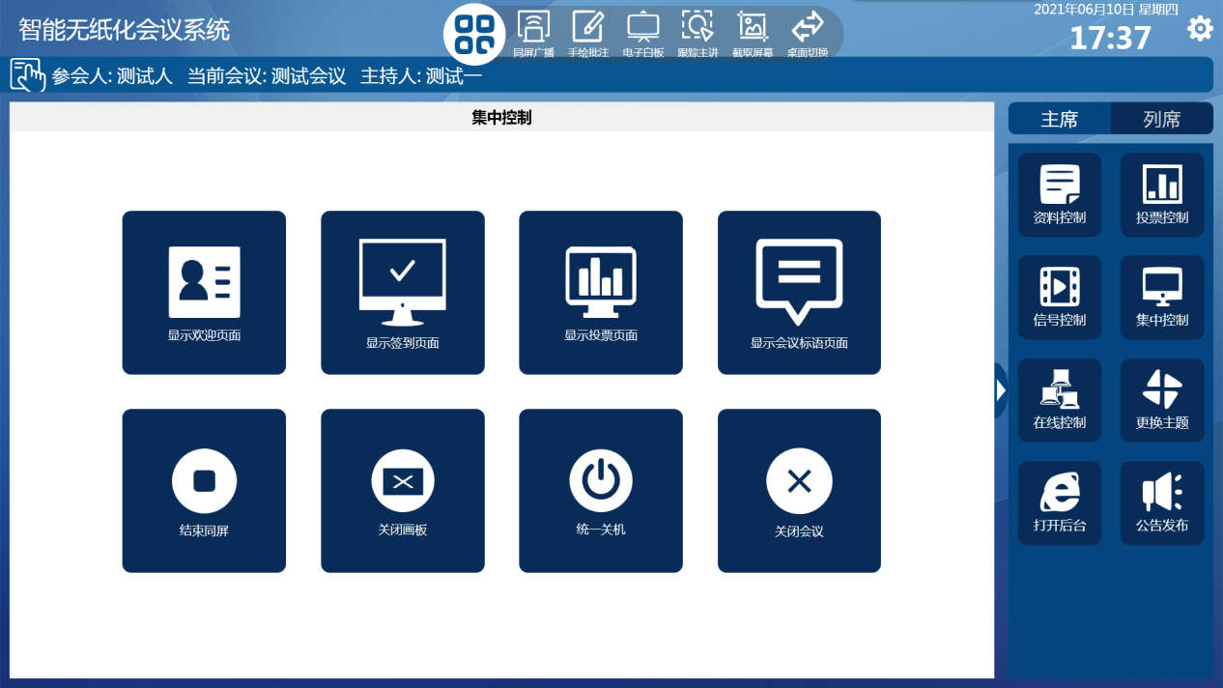

Figure 3.3.4-1 Centralized control interface

### 3.3.5 Online control

Online control allows you to view the online status of the terminal, and you can perform operations such as shutting down\restarting the terminal equipment. As shown in Figure 3.3.5-1.

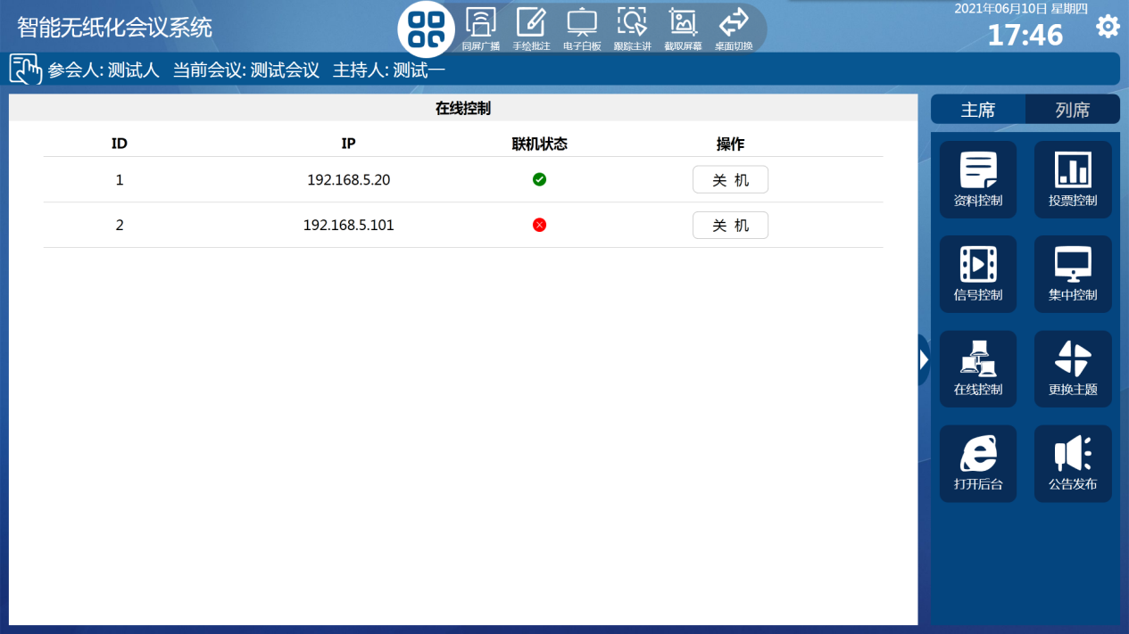

Figure 3.3.5-1 Online Control Interface

### 3.3.6 Change of theme

Theme change can change the theme of all terminals of the meeting with one click. There are a total of 4 preset themes to meet the use of multiple occasions. As shown in Figure 3.3.6-1.

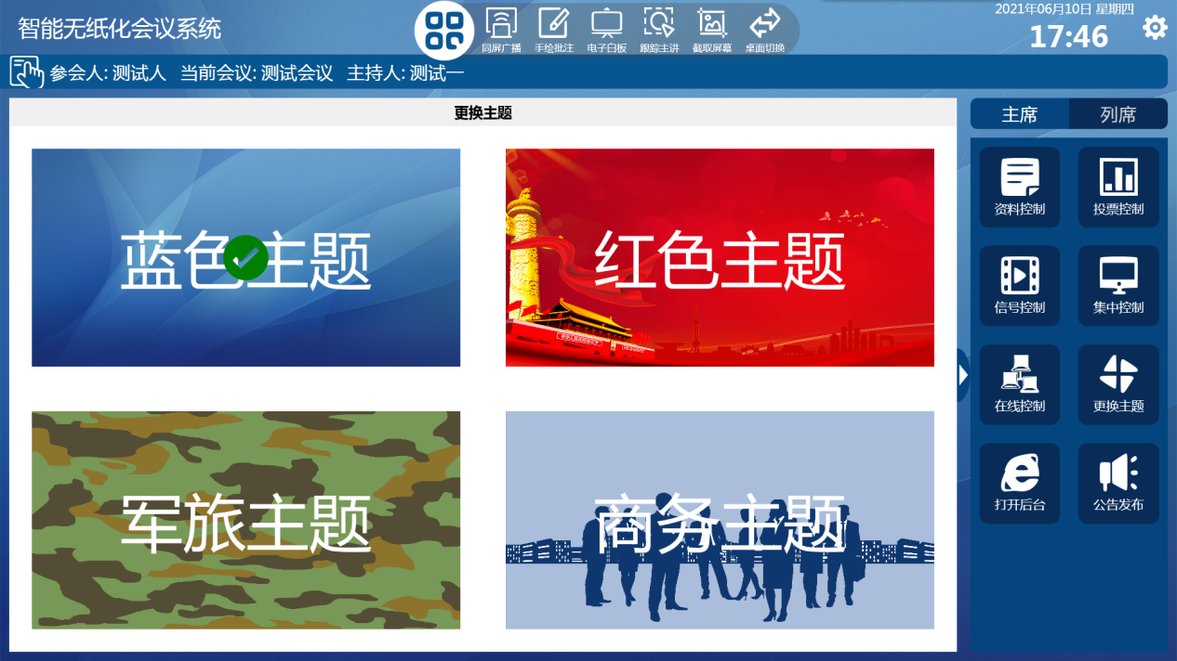

Figure 3.3.6-1 Change Theme Screen

### 3.3.7 Opening the backend

Open the backend to jump directly to the backend management system.

### 3.3.8 Publication of announcements

Announcement Posting allows system notifications to be posted to all endpoints in this session. As shown in Figure 3.3.8-1.

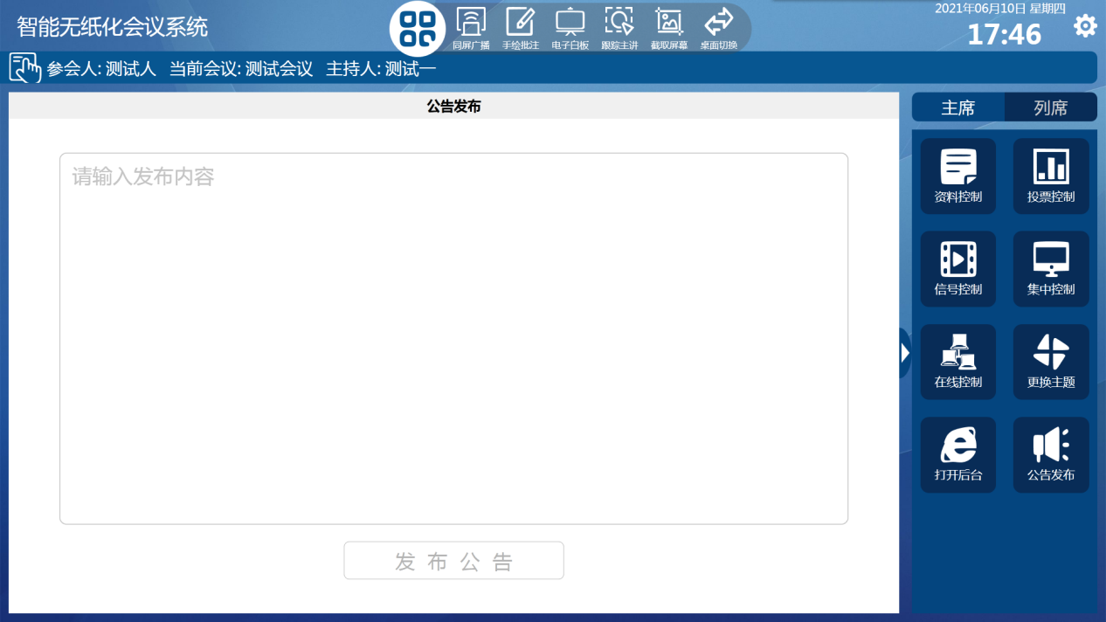

Figure 3.3.8-1 Announcement Posting Interface

## 3.4 Hover Menu



There are 6 menus under the Hover Menu function module. They are same-screen broadcast, hand-drawn annotation, whiteboard, tracking presenter/asynchronous browsing, screen capture, and desktop switching. The menu is zoomable and can be moved to any position.

Simultaneous broadcasting: You can give the interface to any terminal of this conference on the same screen.

Hand-drawn annotations: single- and multi-person interactive annotations of relevant information.

Whiteboard: Single and multi-person interactive use of the whiteboard.

Tracking talk/asynchronous browsing: The endpoints on the same screen can asynchronously browse and exit the same screen at any time, and can return to the same screen by tracking the talk.

Screen Capture: Capture the current screen and save it to the minutes.

Desktop switching: Paperless software and system desktop can be switched with one click.

## 3.5 System setup

Enter the system setting interface through the setting icon at the upper right corner, and you can set the device ID, server IP and port of the terminal.

